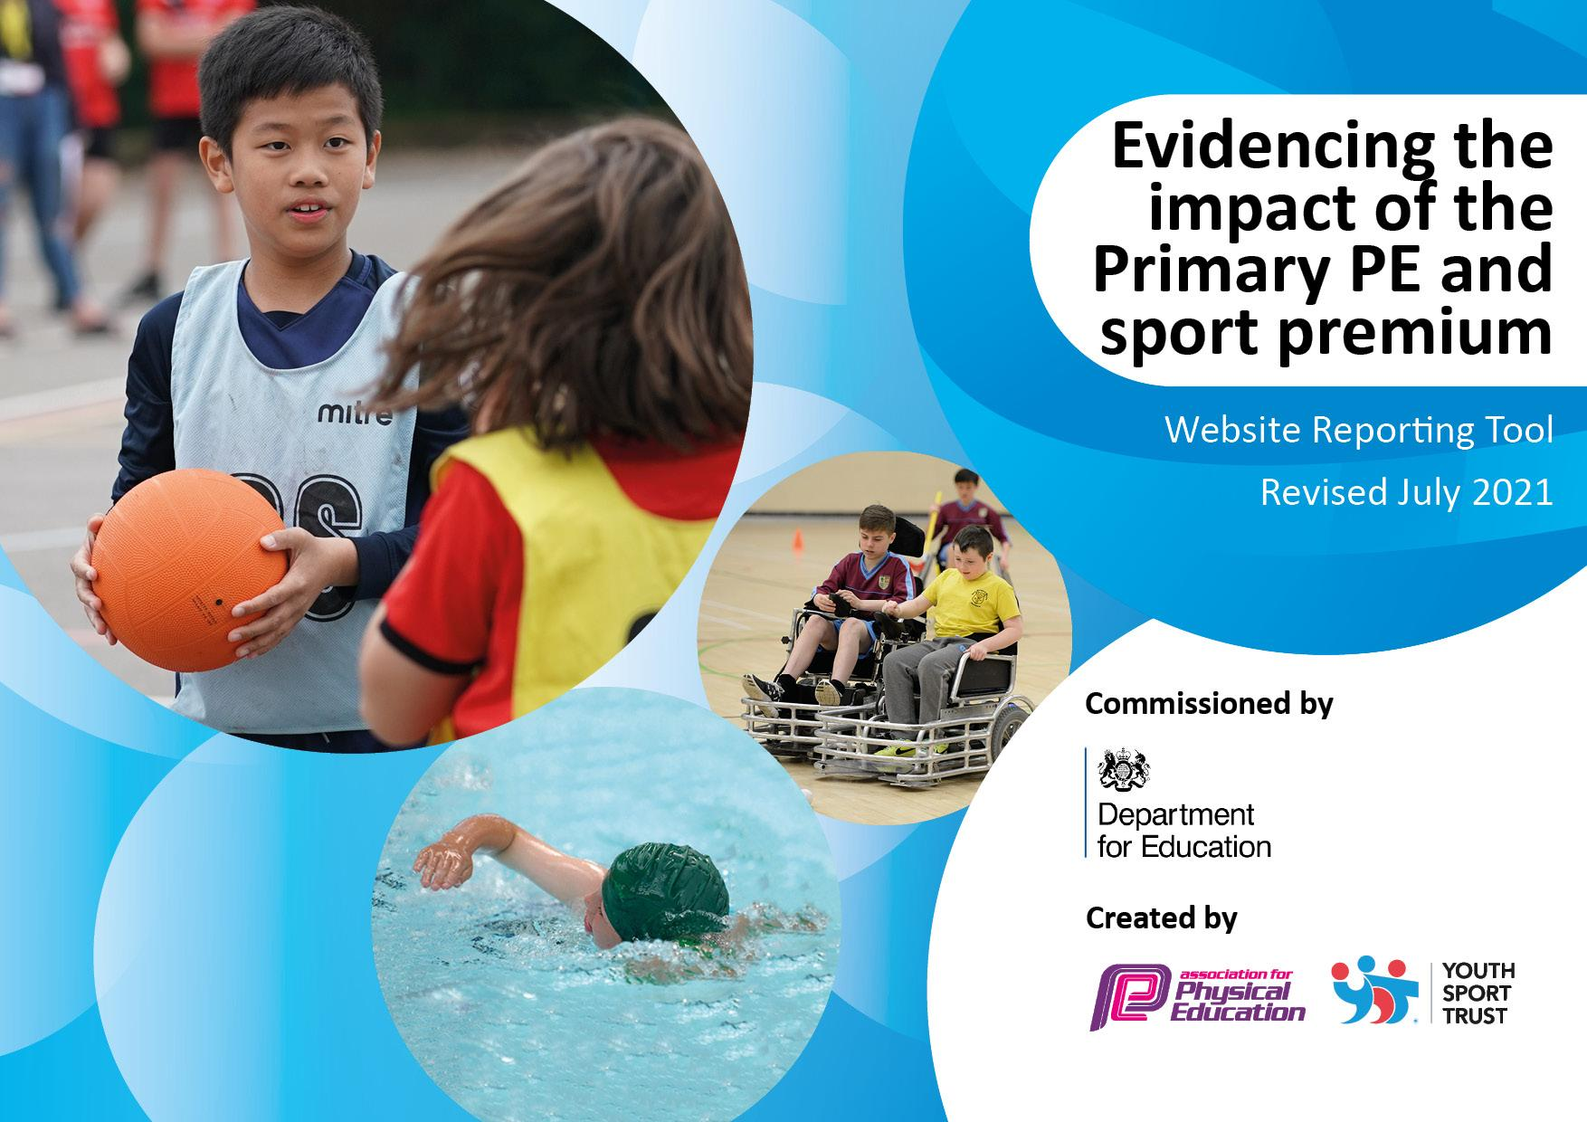
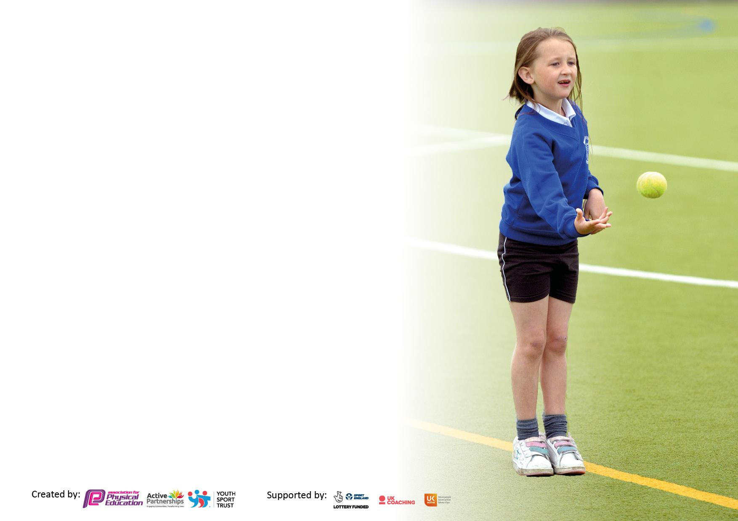

It is important that your grant is used effectively and based on school need. The Education Inspection Framework makes clear there will be a focus on ‘whether leaders and those responsible for governors all understand their respective roles and perform these in a way that enhances the effectiveness of the school’.

Under the Quality of Education Ofsted inspectors consider:
Intent - Curriculum design, coverage and appropriateness
Implementation - Curriculum delivery, Teaching (pedagogy) and Assessment
Impact - Attainment and progress

To assist schools with common transferable language this template has been developed to utilise the same three headings which should make your plans easily transferable between working documents.

Schools must use the funding to make additional and sustainable improvements to the quality of Physical Education, School Sport and Physical Activity (PESSPA) they offer. This means that you should use the Primary PE and sport premium to:

- Develop or add to the PESSPA activities that your school already offer
- Build capacity and capability within the school to ensure that improvements made now will benefit pupils joining the school in future years
- The Primary PE and sport premium should not be used to fund capital spend projects; the school’s budget should fund these.

Pleasevisitgov.ukfortherevisedDfEguidanceincludingthe5keyindicatorsacrosswhichschoolsshoulddemonstrate animprovement.Thisdocumentwillhelpyoutoreviewyourprovisionandtoreportyourspend.DfEencouragesschools to use this template as an effective way of meeting the reporting requirements of the Primary PE and sport premium.

We recommend you start by reflecting on the impact of current provision and reviewing the previous spend.

Schools are required to publish details of how they spend this funding, including any under-spend from 2019/2020, as well as on the impact it has on pupils’ PE and sport participation and attainment. All funding must be spent by 31st July 2022.

We recommend regularly updating the table and publishing it on your website throughout the year. This evidences your ongoing self-evaluation of how you are using the funding to secure maximum, sustainable impact. Final copy must be posted on your website by the end of the academic year and no later than the 31st July 2021. To see an example of how to complete the table please click HERE.


Created by: Supported by:

Details with regard to funding
Please complete the table below.

Total amount carried over from 2021/22 | £
Total amount allocated for 2022/23 | £18400
How much (if any) do you intend to carry over from this total fund into 2023/24? | £0
Total amount allocated for 2023/24 | £18400
Total amount of funding for 2023/24. To be spent and reported on by 31st July 2024. | £18400

Swimming Data
Please report on your Swimming Data below.

Meeting national curriculum requirements for swimming and water safety.

N.B. Complete this section to your best ability. For example you might have practised safe self-rescue techniques on dry land which you can then transfer to the pool when school swimming restarts.
Due to exceptional circumstances priority should be given to ensuring that pupils can perform safe self rescue even if they do not fully meet the first two requirements of the NC programme of study
What percentage of your current Year 6 cohort swim competently, confidently and proficiently over a distance of at least 25 metres?  N.B. Even though your pupils may swim in another year please report on their attainment on leaving primary school at the end of the summer term 2021.  Please see note above | %
What percentage of your current Year 6 cohort use a range of strokes effectively [for example, front crawl, backstroke and breaststroke]?  Please see note above | %
What percentage of your current Year 6 cohort perform safe self-rescue in different water-based situations? | %
Schools can choose to use the Primary PE and sport premium to provide additional provision for swimming but this must be for activity over and above the national curriculum requirements. Have you used it in this way? | Yes/No

Action Plan and Budget Tracking
Capture your intended annual spend against the 5 key indicators. Clarify the success criteria and evidence of impact that you intend to measure to evaluate for pupils today and for the future.

Academic Year: 2023 to 2024 | Total fund allocated: | Date Updated: 30.6.24
Key indicator 1: The engagement of all pupils in regular physical activity – Chief Medical Officers guidelines recommend that primary school pupils undertake at least 30 minutes of physical activity a day in school |  |  |  | Percentage of total allocation:
 |  |  |  | 61%
Intent | Implementation |  | Impact
Your school focus should be clear what you want the pupils to know and be able to do and about  what they need to learn and to  consolidate through practice: | Make sure your actions to achieve are linked to your intentions: | Funding allocated: | Evidence of impact: what do pupils now know and what can they now do? What has changed?: | Sustainability and suggested next steps:
All pupils receive 2 hours of PE per week. Pupils can talk about their learning and why physical activity is important.  EYFS pupils receive one specific PE lesson per week, alongside physical development through continuous provision activities.  Children engage in other opportunities for physical activity throughout the school week, such as wake up shake up, active break times and lunchtimes. | Teachers timetable two PE lessons per week, one lesson per week in EYFS.  Sports leader employed at lunchtimes to lead activities across KS2.  Young sports leaders set up to engage KS1 in activities at lunchtime. | £11335 | Jan 24 update:  All classes accessing 2 PE lessons a week, close to 2 hours.  Wake Up Shake Up taking place daily, with children entering school more positively and ready to learn. | Review the PE overview for the year and ensure all equipment is purchased at the beginning of each term.  Liaise with lunchtime coach to track children taking part in lunchtime activities on offer - registers taken.  Review playtime equipment and activities available to encourage active playtimes.
Key indicator 2: The profile of PESSPA being raised across the school as a tool for whole school improvement |  |  |  | Percentage of total allocation:
 |  |  |  | 5%
Intent | Implementation |  | Impact
Your school focus should be clear what you want the pupils to know and be able to do and about  what they need to learn and to  consolidate through practice: | Make sure your actions to achieve are linked to your intentions: | Funding allocated: | Evidence of impact: what do pupils now know and what can they now do? What has changed?: | Sustainability and suggested next steps:
Pupils see all staff wearing PE kit when teaching, which increases profile of PESSPA and encourages children to be more actively involved in lessons.  PE display updated with events, results and curriculum updates. Children see what other classes are covering and what they can aim for in future year groups.  Pupils in school are aware of updates, events and results across the school year. | Staff encouraged to wear kit when teaching. Remind children of importance of wearing appropriate kit for physical activity.  Display updated once a month.  Sports leaders share information and results during celebration assembly, once per half term. | £1000 | Jan 24 update:  Staff are much more confident when teaching PE lessons, with all staff wearing school PE kit for all lessons. Children are now able to see the importance of PE lessons better. | Use Friday assembly to celebrate recent sporting achievements in school.  Use newsletter to include sports report section (possibly written by sports council).  Purchase school football kits for boys and girls.

Key indicator 3: Increased confidence, knowledge and skills of all staff in teaching PE and sport |  |  |  | Percentage of total allocation:
 |  |  |  | 16%
Intent | Implementation |  | Impact
Your school focus should be clear | Make sure your actions to | Funding | Evidence of impact: what do | Sustainability and suggested
what you want the pupils to know | achieve are linked to your | allocated: | pupils now know and what | next steps:
and be able to do and about | intentions: |  | can they now do? What has
what they need to learn and to |  |  | changed?:
consolidate through practice:
All staff confident in teaching PE and understand how to deliver curriculum. | Weekly briefing sessions used to give advice and guidance to staff.  Staff meeting held once a term to focus on concerns and areas for development for staff.  Updated guidance sent out to staff when needed. | £2105.34 | Jan 24 update:  All problems dealt with by PE coordinator, to ensure staff are confident in delivering PE lessons. Overview for the year sent out several times to remind staff of coverage, and a half termly timetable sent out to ensure staff can timetable their PE lessons without conflict with other classes. | Purchase kit for any new staff.  Look for any further CPD opportunities (workshops, trips etc).  Staff questionnaire completed at the beginning of next year.
Key indicator 4: Broader experience of a range of sports and activities offered to all pupils |  |  |  | Percentage of total allocation:
 |  |  |  | 9%
Intent | Implementation |  | Impact
Your school focus should be clear | Make sure your actions to | Funding | Evidence of impact: what do | Sustainability and suggested
what you want the pupils to know | achieve are linked to your | allocated: | pupils now know and what | next steps:
and be able to do and about | intentions: |  | can they now do? What has
what they need to learn and to |  |  | changed?:
consolidate through practice:
Updated curriculum to ensure coverage across all areas of the PE curriculum.  Termly workshops held for all children to try new sports.  OAA focus – climbing, watersports  Playground environment provides opportunities for children to explore, play and compete in a range of sports | Monitor across the year to ensure all of the curriculum is being delivered, and resources are fully stocked.  PE lead to take one day out of class a half term to monitor and assess.  Y6 climbing sessions booked in September.  Years 1 – 6 to complete activities at Trafford Watersports, one day.  Playground markings updated to aid with organising PE lessons and lunchtime games. | £1700.17 | Jan 24 update:  Curriculum being delivered as outlined on overview; children accessing a broad range of sports and will revisit certain sports in later year groups, providing progression in skills and knowledge of rules/technique.  Year 6 completed climbing course in Autumn. All children completed this, with several saying they would continue outside of school. They have been exposed to an activity they wouldn’t normally try in school.  Cricket engagement day organised for Spring 2 - classes 1 - 6 to take part.  Girls Tag Rugby festival for Years 5 and 6 in Spring 2. | Review PE overview in September.  Look for opportunities for external visits to sports clubs/competitions or for providers to come into school.  Explore links with local clubs.

Key indicator 5: Increased participation in competitive sport |  |  |  | Percentage of total allocation:
 |  |  |  | 9%
Intent | Implementation |  | Impact
Your school focus should be clear | Make sure your actions to | Funding | Evidence of impact: what do | Sustainability and suggested
what you want the pupils to know | achieve are linked to your | allocated: | pupils now know and what | next steps:
and be able to do and about | intentions: |  | can they now do? What has
what they need to learn and to |  |  | changed?:
consolidate through practice:
Membership of Manchester Schools PE association.  Years 5 – 6 given opportunity to compete in inter-school and intra-school competitions across the year.  Year 3 – 4 take part in intra-school competitions. | Book onto events at the beginning of each term: cross country, football, cricket, basketball, tennis  Termly lunchtime competitions held on astro turf.  Lunchtime sports leaders organise end of term competitions at lunchtime | £1648.33 | Children in KS2 have experienced inter-school competition, and all children experienced intra-school competition.  Several lunchtime football competitions held.  Coach-led competition taking place at lunchtime. | Timetable for consistent end of half term competitions across key stages - combine classes and compete in house teams at the end of each half term. Liaise with lunchtime coach to organise these at lunchtime.

Signed off by
Head Teacher:
Date:
Subject Leader: | Tom Butler
Date: | 12.7.24
Governor:
Date:

